PAC-POLY-Tahiti-NE View-Cook-1777

## he North East View of The Island of Otaheite

32.5 cm x 20.5 cm copperplate engraving, 38 cm x 24 cm sheet size, Alexander Hogg, London, 1785

We are pleased to offer this scarce fine art print showing canoes off the coast of Tahiti after a drawing by ship's artist [William Hodges](http://en.wikipedia.org/wiki/William_Hodges) (1744-1797) on Captain James Cook's second voyage of discovery and engraved for the *New, Authentic, Entertaining, Instructive, Full and Complete Historical Account of Captain Cook's First, Second, Third and Last Voyages*[1](http://vi.vipr.ebaydesc.com/ws/eBayISAPI.dll?ViewItemDescV4&item=261699709478&t=1395522164000&tid=10&category=360&seller=regiomontanus&excSoj=1&excTrk=1&lsite=0&ittenable=false&domain=ebay.com&descgauge=1" \l "1) published serially between 1784 and 1786.  Trained as a landscape artist, Hodges's orders from the Admiralty as conveyed to Cook were to "diligently employ himself in making Drawings or Paintings of such Places as you may touch that may be worthy of notice in the course of your Voyage as also of other Objects and things as may fall within the Compass of his Abilities", orders that Hodges certainly met as his later oil paintings of scenes from the voyage attest.  Probably sketched from the *Resolution* at anchor during their stay in August and September 1773, Hodges conveys a typical "delightful prospect" that Cook and his crew found so congenial in Tahiti.  This example of the print exhibits fine hand colour in keeping with the palette favoured by Hodges in his post-voyage oil paintings and will make a elegant presentation if matted and framed as well as an important addition to any collection related to Tahiti or the explorations of James Cook.

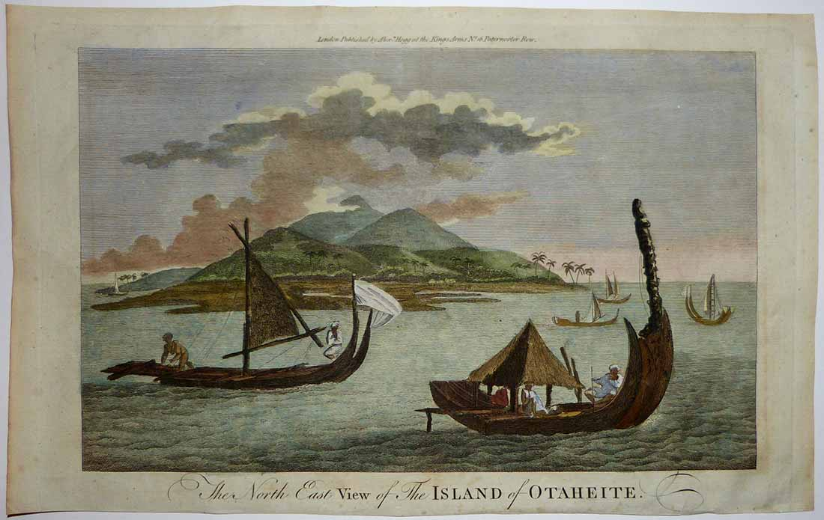

To get a sense of print detail consider that crude mainmast of this canoe as seen below measures just 8 cm long actual size:

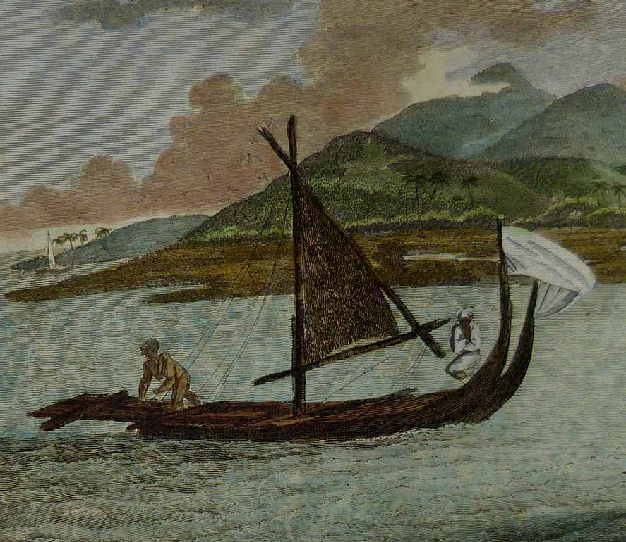

Note shaded seating area:

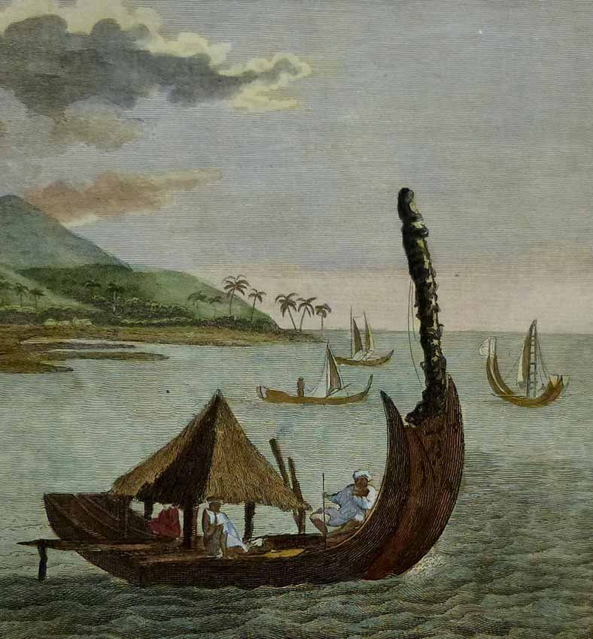

Condition - Please note carefully:  The print is in overall very good condition as can be ascertained from photos, strong impression on fine quality laid paper, image area essentially pristine, no text on verso, no folds.  Close and somewhat uneven trim to top and bottom margins, trivial scattered soiling to margin extremities, minor creases in center top margin with a few just crossing into image area.  Very faint vertical line of offset in right margin just outside image area and even fainter conjugate offset line in sky along far left edge, scarcely discernible.  Image of print shows it laying flat in free state with all edges shown for evaluation,  [Inquiries](mailto:jfazli@ix.netcom.com) welcome and we encourage you to visit our other [listings](http://cgi6.ebay.com/aw-cgi/eBayISAPI.dll?ViewListedItems&userid=regiomontanus&sort=3&since=-1) on eBay.  
  
NOTES:  
  
1. The editor of the *New, Authentic, Entertaining, Instructive, Full and Complete Historical Account of Captain Cook's First, Second, Third and Last Voyages* was named as one "George William Anderson",  almost certainly a pseudonym for the publisher Alexander Hogg.  In a recent exhibition of these historically important engravings made for this publication the Lowe Art Museum in Miami noted that the pseudonym was "a device Hogg employed in a number of his publications" intended to convey an "aura of authoritative knowledge" regarding his editing of the official publications of the voyages.  Hogg shrewdly elected to publish the work (which eventually included accounts of other circumnavigations) in a relatively affordable serial format from 1784-1786 to reach a broad audience, noting in his marketing copy that this was "due to the many thousands of Persons who would wish to peruse the Discoveries... and view the astonishing fine Copper-Plates, who have hitherto been excluded from gratifying their eager curiosity.  These installments would allow every Person, whatever may be his Circumstances, to read about the voyages of which such vast Sums of the Public Money have been expended."  Note that we are offering this "astonishing fine Copper-Plate" as published and without hand colour - while some of the engravings after Hodges's drawings lend themselves quite nicely to modern hand colour, this print is not in that category as the result would inevitably obscure the engraved line of such a strong impression.